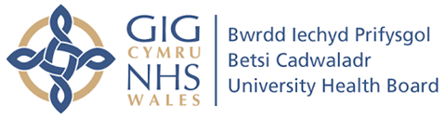
North Wales Community Dental

NEBDN Level 3 DIPLOMA
DENTAL NURSING
Training Programme

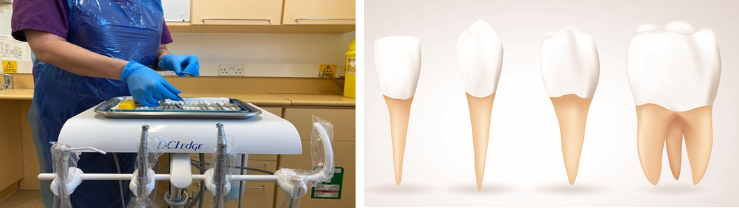
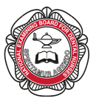
September 2022
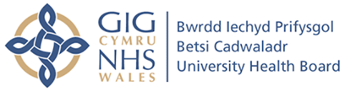
Course Overview
The NEBDN National Diploma in Dental Nursing is a General Dental Council (GDC) recognised dental nursing qualification, which covers all outcomes, described within the GDC Preparing to Practice document.
The purpose of the qualification is to prepare trainee Dental Nurses in the foundations of dental nursing, so they can demonstrate the highest standards in terms of knowledge, skills and professional attributes.
The skills you will gain upon completion of the qualification are described within the extensive curriculum under the domains of Clinical, Communication, Professionalism and Management and Leadership.
The qualification comprises of a formative workplace assessment the Record of Experience, which enables the workplace team to become an integral part of the training of the trainee Dental Nurse.
The summative assessment comprises a written and practical component aimed at assessing knowledge and decision making to demonstrate trainee Dental Nurses understanding and competence.
The summative assessment also adheres to current educational best practice.
The result is a qualification that we are proud of – one, which enhances teamwork within the dental practice and gives peace of mind to both trainee and dental practice that they have completed a robust qualification and can look forward to a fulfilling career within the dental profession
Begin your learning today

Entry Requirements
- Currently employed as a Trainee Dental Nurse

- Working at least 3 days chairside

- Hold a Certification in English Language GCSE or equivalent

- Have the support of an employer

- Be assigned to a Mentor/s who must be qualified and registered with the GDC

- Committed to attend weekly training

- Have access to a computer with internet access

For further information and an application pack, contact:
Tracey Taylor, Lead Tutor
Tracey.Taylor6@wales.nhs.uk

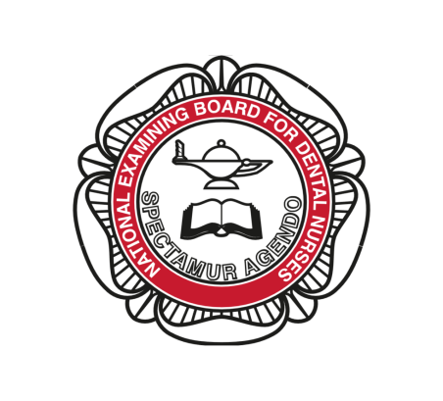

NEBDN National Diploma in Dental Nursing
Application Form 2022 – 2024

I wish to apply for a place on the Wrexham Dental Nurse Course 2022-2024
Name

Date of Birth

Home Address

Personal Contact Number (mobile if possible for urgent communications)

Email address

Name of Principal

Practice Address

Postcode

Telephone Number

Principle Dentist GDC Number

How long have you been employed as a Trainee Dental Nurse?

Do you need assistance with any of the following? YES / NO

Reading

Writing

Numbers

Study Skills

Would you like to talk to someone about your needs? Yes / No

Please return completed form to:
Ms T Taylor
Education & Training Office
Wrexham Dental Centre, Grove Road, Wrexham, LL11 1DY
gsargare
Cymuned Deintyddol Gogledd Cymru

NEBDN Lefel 3 DIPLOMA
NYRSIO DEINTYDDOL
Rhaglen Hyfforddi

Medi 2022
Trosolwg o’r Cwrs
Mae diploma Cenedlaethol NEBDN mewn
Nyrsio Deintyddol yn cael ei gydnabod gan Y Cyngor Deintyddol Cyffredinol (CDC)(GDC) Yn cwmpasu pob canlyniad sydd wedi ei ddisgrifio o fewn y ddogfen (CDC) Paratoi i Ymarfer.

Pwrpas y cymhwyster yw paratoi Nyrsus Deintyddol
Hyfforddeion, mewn sylfaeni nyrsio deintyddol fel ei bod yn gallu arddangos y safonau uchaf mewn termau, gwybodaeth, sgiliau a nodweddion proffesiynol.

Mae’r sgiliau y byddwch yn ennill wrth gwblhau’r cymhwyster wedi ei disgrifio o fewn y cwricwlwm eang o dan y parthau Clinigol, Cyfathrebu, Proffesiynoldeb, Rheoli ac Arwain.

Mae’r cymhwyster yn cynnwys asesiad ffurfiannol yn y gweithle sef y Cofnod o Brofiad, sy’n galluogi tîm y gweithle i fod yn rhan annatod o hyfforddi’r Nyrs Deintyddol hyfforddedig.

Mae’r asesiad crynodol yn cynnwys cydran ymarferol ac ysgrifenedig, wedi ei anelu at asesu gwybodaeth a gwneud penderfyniadau i ddangos deallusrwydd a chymhwysedd y nyrs ddeintyddol dan hyfforddiant.

Mae’r asesiad crynodol yn glynu i arferion gorau addysgol presennol.

Y canlyniad yw cymhwyster yr ydym yn falch ohono, un, sydd yn gwella gwaith y tîm o fewn y practis deintyddol, ac yn rhoi tawelwch meddwl nid yn unig i’r hyfforddai ond hefyd i’r ddeintyddfa fel eu bod wedi cwblhau cymhwyster cadarn, ac y gall edrych ymlaen at yrfa foddhaus o fewn y proffesiwn deintyddol.

Dechreuwch eich Dysgu Heddiw

Entry Requirements

• Yn gyflogedig ar hyn o bryd fel Nyrs Deintyddol hyfforddedig
• Yn gweithio 3 diwrnod o leiaf yn glinigol
• Yn dal cymhwyster mewn Iaith Saesneg GCSE neu gyfwerth
• Yn cael cefnogaeth gan ei chyflogwr
• Wedi ei neilltuo I Fentor/ Fentoriaid sydd yn Gymwysiedig ac wedi cofrestru â’r GDC
• Yn gwbl ymroddedig i fynychu Hyfforddiant wythnosol
• Mynediad rhwydd i gyfrifiadur a’r rhyngrwyd

Am fwy o wybodaeth a pecyn cais Cysylltwch â:
Tracey Taylor, Tiwtor Arweiniol
Tracey.Taylor6@wales.nhs.uk

Diploma Cenedlaethol mewn Nyrsio Deintyddol NEBDN
Ffurflen Cais 2022 – 2024

Hoffwn wneud cais am le ar gwrs Nyrs Deintyddol yn Wrecsam 2022-2024
Enw

Dyddiad Geni

Cyfeiriad Cartref

Rhif cyswllt personol (Rhif ffon symudol rhag ofn bod angen cyfathrebu brys)

Cyfeiriad ebost

Enw Pennaeth y Practis

Cyfeiriad y practis

Côd Post

Rhif ffon y practis

Rhif GDC Ddeintyddol y Pennaeth

Pa mor hir ydych wedi bod yn gyflogedig fel Nyrs Ddeintyddol

dan hyfforddiant?

A oes angen cymorth arnoch gydag unrhyw un o’r canlynol? OES / NACOES

Darllen

Ysgrifennu

Niferoedd

Sgiliau astudio

Hoffech chi siarad â rhywun am eich anghenion? Ia / Na

Dychwelwch y ffurflen wedi’i chwblhau os gwelwch un dda i:
Ms T Taylor
Education & Training Office
Wrexham Dental Centre, Grove Road, Wrexham, LL11 1DY

