REPORT

LDC conference 2022 – Newport Wales

Summary of events.

Jeremy Williams and Dan Naylor attended the conference as representatives of the Committee. Unfortunately, we had not been able to submit motions in a timely fashion this year but we were both keen to engage in the event, especially with it being hosted in Wales.

The Thursday night began with a drink’s reception and dinner in the ICC, outside of Newport. Having checked in to the accommodation provided by conference, in the Celtic Manor, it was a short walk across to the venue. We were seated on the Welsh Table along with colleagues from Gwent and Cwm Taff. There was a small Welsh contingent of 8on our table for the evening and the dinner was led by the Conference chair and local Welsh practitioner Dan Cook. The meal was nice, and we were entertained by the Cardiff Male Voice choir which was fantastic. Dan Naylor managed to guess the exact time for the chair’s speech would last so won the cash prize which was kindly donated back to the dentist’s benevolent fund after hearing the frightening statistic that the average age of claimants now has dropped from 49 to 24!
A few beers afterwards and it was off to bed for an early start.

Conference

This year the conference was memorable not for who attended but who did not! There was no representation from UK government or the DOH with the sole representative to speak being the new CDO from Wales, Andrew Dickenson, and even he was virtual from Germany.

After Dan Cook’s chair’s address, Len D’cruz from BDA indemnity spoke briefly about vicarious liability and the importance of cover for those with Limited companies. We then had a damning assessment of the state of dentistry in England from Shawn Charlwood, chair of GDPC and some questions from the floor. This highlighted the complete misunderstanding that the government in England has for the serious problems faced by the profession from dentist training through to workforce issues and practice running and ownership. His considered view was that English dentistry is in the A+E department and the DOH is not very proficient in its resuscitation attempts. He highlighted that since the pandemic 3000 dentists had left the profession but behind that statistic, for every one that had left, 10 had reduced their contract.

Motions then ran until the break with main English based proposals put forward. Jeremy and Dan were able to vote on a few with the underlying theme on contract change and workforce review. After break we had a short presentation from John Milne from the CQC who shared a few slides about the approach they were taking with practice inspections and the criteria they are using to score practices. Some changes were discussed in terms of a new scoring system which led to a few challenges from the floor but, overall, it had little relevance for us in Wales. He was followed by Stefan Czerniawski from the GDC who advised us of the new workforce audit commissioned by the GDC and its publication on their website

https://www.gdc-uk.org/news-blogs/news/detail/2022/06/09/new-covid-19-dental-research-indicates-system-being-overstretched

Russell Gidney was then given a chance to introduce the Welsh CDO, Andrew Dickenson. He spoke for around 20 minutes explaining that he is new to the job and is not yet able to comment fully on the new contrast and the reform program. He acknowledged the shortcomings in the data collection process and its evolution needing time. He stressed this is a test year and that lessons were being learned as to how to proceed. He discussed the importance of the team and the need for better ways of working by working upstream and not focussing on the events further down the stream?

The afternoon began with the British Dental guild’s request for funds and then a panel discussion about the future of dentistry, led by Alan Suggett, an accountant from NASDAL. He produced some interesting information regarding actual pay for principals over the last 15 years and it was shocking to see, in real terms, the reduction in actual pay for associates and principles.

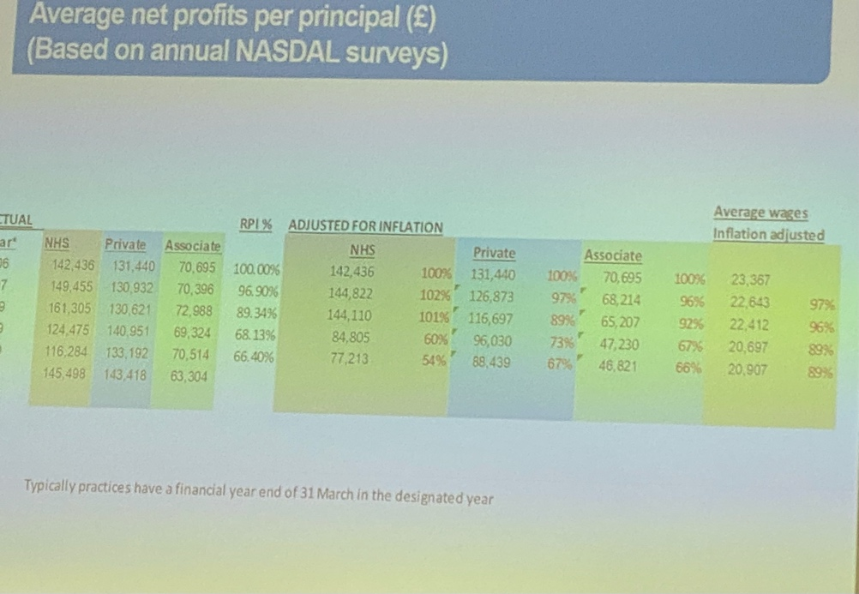

We heard from Lauren Harrhy from Confidental

https://www.confidental-helpline.org

who stressed that their service is for dentists struggling with their mental health and asks for LDCS to circulate the details above.

Further motions were presented including a couple for Wales that were carried. These were all based around the inclusion of a GDP in any further reform or contract development.
The day was ended by a transfer of chair to Mark Green from Yorkshire and thanks to all the team that took part in the excellent organisation to make the event run so well.

The plan is for the event to take place in Harrogate next year and I would call on North Wales to be better represented by more of the committee as it really is a good day that can provide a great insight into the work the GDPC and LDCS do for the profession.

Dan Naylor

Dr Dan Naylor
Secretary
E:sec.nwldc@gmail.com
T:01978364390

