NORTH WALES LDC MEETING MAY 15th 2023

6:30pm

THE PENSION QUESTION

The North Wales LDC is delighted to have a guest speaker for this online event.
The meeting will take place from 6:30pm on Monday 15th May and include a presentation followed by a Q+A with Phil.
With the uncertainty surrounding the NHS contracts, superannuation, pension limits and other aspects of future planning, Phil has agreed to cover several topics and be open to
Questions afterwards.

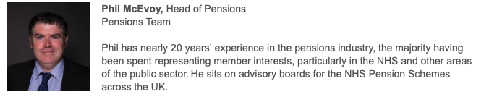

Aims and Objectives

- To understand how the UK pension system works, including state pension and private pensions
- To introduce the NHS Pension Scheme
- To outline how the NHSPS works for GDPS
- Describe recent changes to retirement processes in the NHS
- Understanding of the taxation of pension savings
- Outline the Age Discrimination remedy (McCloud) for public service pensions

The Meeting is free to attend and will be delivered virtually on Zoom. A meeting link will be made available on the LDC website’s calendar along with our Facebook page. Please follow https://us02web.zoom.us/u/kd9tDvFzp and join from 6:30pm on the Monday.

Dr Dan Naylor
Secretary
E:sec.nwldc@gmail.com
T:01978364390

